**Assignment 2**

**Part 1:** In this part, you’ll develop an application that tells how many quarters, dimes, nickels, and pennies are needed to make change for any amount of change from 0 through 99 cents. One way to get the results is to use the divide and modulus operators along with the parseInt method for truncating the results so they are whole numbers.

* Open the HTML and JavaScript files in this folder:
* \change_maker\
* Then, run the application to see the user interface shown above, although that interface won’t do anything until you develop the JavaScript for it.
* You are not allowed to modify the html or the css code. Your JavaScript code must be written in the make_change.js
* Code an event handler named processEntries that gets the user’s entry and checks to make sure that it is a number between 0 and 99. If it isn’t, display an alert dialog box for the error. If it is valid, call a function named makeChange and pass it the user’s entry.
* Code the makeChange function, which should have one parameter that accepts the user’s entry. This function shouldn’t return anything, but it should display the results in the text boxes for Quarters, Dimes, Nickels, and Pennies.
* Code an onload event handler that attaches the processEntries event handler to the click event of the Make Change button. Then, test this application.

**Part 2:** In this part, you’ll use radio buttons to determine whether the conversion is from Fahrenheit to Celsius or vice versa. You’ll also modify the DOM so the labels change when a radio button is clicked. When the application starts, it will look like this:

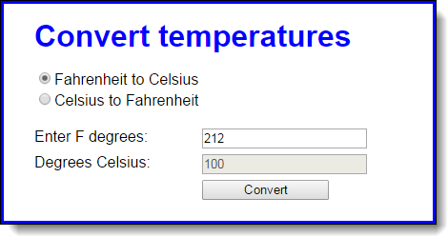

When the user clicks on the second radio button, the labels will change so the interface will look like this:

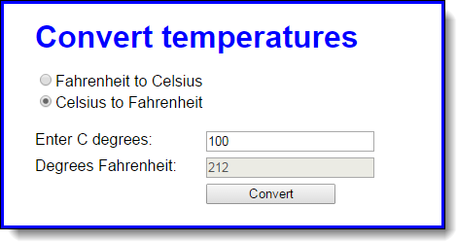

* Open the HTML and JavaScript files in this folder: convert_temps
* Code the implementation for a function clearTextBoxes which will clear the text boxes.
* Code the implementation for the onload event handler that attaches three event handlers named convertTemp, toCelsius, and toFahrenheit.
* Code the toFahrenheit function that is executed when the user clicks on the second radio button. It should change the text in the labels for the text boxes so they read as in the second interface above. It should also call the clearTextBoxes function to clear the text boxes.
* Code the toCelsuis function that is executed when the user clicks on the first radio button. It should change the text in the labels for the text boxes so they read as in the first interface above. It should also call the clearTextBoxes function to clear the text boxes.
* Code the convertTemp function without any data validation. It should calculate the temperature based on which button is checked. To convert Fahrenheit to Celsius, first subtract 32 from the Fahrenheit temperature, and then multiply that result by 5/9. To convert Celsius to Fahrenheit, first multiply Celsius by 9/5, and then add 32. The result in either case should be rounded to zero decimal places.
* Add data validation to the convertTemp function. The only test is whether the entry is a valid number. If it isn’t, this message should be displayed in a dialog box: “You must enter a valid number for degrees.”
* Add any finishing touches to the application like moving the focus to the first text box whenever that’s appropriate.

# Submission

You are required to submit 2 files and deploy your assignment to dev.fast.sheridanc.on.ca:

1. Upload a zip/rar folder (assign2.zip) to dropbox on Slate.
2. Upload A text document containing your JavaScript source code.
3. **Deploy your assignment to dev.fast.sheridanc.on.ca.**
   1. All your project directories should be uploaded into the assign2 folder.
   2. Your are going to lose 40% of your mark if you don’t deploy your website to  https://login.dev.fast.sheridanc.on.ca/assign2